Autumn/Spring/Summer 2026 Headteacher report to governors
Executive summary
Indicator | Current | Previous | Nat. Av. | Key changes since last report/notes
NOR
%SEND
%EHCP
%Pupil Premium
%FSM
%LAC/PLAC
Whole school attendance
SEND attendance
LAC attendance
FSM attendance
Whole school PA (10% or more missed)
Number of serious absentees (50% or more missed)
Safeguarding CP
Safeguarding CIN
Safeguarding TAF
KS2 RWM combined
Y4 MT
Y1 phonics
GLD
GDPR breach
GDPR FOI/SAR
OFSTED IDSR dashboard | Include link to dashboard
Headlines for governors:
- Attendance is good – comment
- Comment: re suspensions or exclusions
What are working on re attendance/behaviour :
- Comment

- Introduction
Summary comment about the term so far

NOR in each year group: boys/girls:

Example table
EYFS | Year 1 | Year 2 | Year 3 | Year 4 | Year 5 | Year 6
31  16/15 | 30  17/13 | 29  17/12 | 32  15/17 | 29  15/14 | 27  18/9 | 28  10/18

- Safeguarding
Lead governor - name
Key data: link to safeguarding termly report from HT
Referrals (since the last meeting) – comment
CPOMS CP Data (first column is monitored incidents, second column is number of incidents, not children, since Sept.)
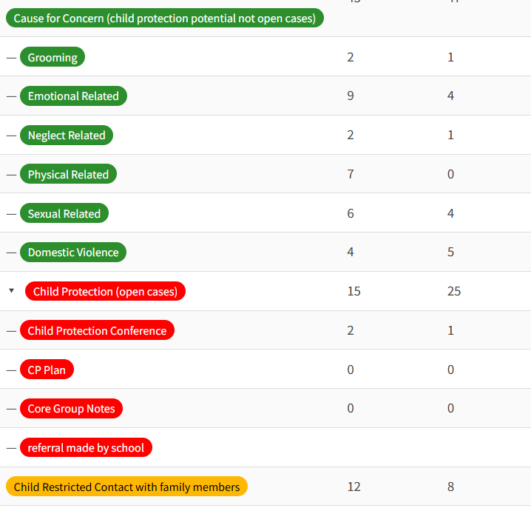
Filtering and monitoring alerts (since the last meeting) number Link to filtering and monitoring alerts record
Operation Encompass alerts - number
Compliance: Ofsted agreed that “safeguarding standards are met”
Link to school’s AI statement

Support from external agencies – (some examples – insert your own)
- Young Carers
- Brentwood Catholic Children’s Society (weekly Play Therapy)
- Anglia Ruskin University/SCITT (Trainees and Mentors)
- Diabetic Nurse (Yr 2 pupil)
- Physical, Neurological Impairment Team (EHCP in Yr 1)
- Great Ormond Street Hospital (and various other medical staff for pupils in Yrs 1, 2 and 4)
- Essex and Surrey Virtual Schools (and various social care professionals) Ask the Headteacher
- South Woodham Ferrers Library
Key successes:
Training: example
Risks/emerging issues: example

- Leadership and governance
Strategic improvement plan
- Progress summary
- IDSR
- SLT monitoring Strategy Monitoring Tracker
Financial overview examples of attached reports
- Budget summary – share with governors
- PPG impact
- Sports Premium impact

Staffing update
- Recruitment - commentary
- Absence + breakdown as sessions as appropriate
- ECTs - commentary
- Other -

- Curriculum and Teaching
Quality of teaching
- Teaching summary – including headlines observations, monitoring and feedback See ECT and Monitoring Tracker above.
- Staff receiving support – if applicable (numbers, not names)
Curriculum
- Areas of strength -
- Areas for development -
- Key focus-
Targeted interventions and personalised learning strategies need SEND Visit link
- Progress
- Learning
- Achievement
Attainment and progress data link to DfE attendance report
- Latest Termly data link to e.g. assessment week data
- Comparison to targets and starting points
- Key groups
- Emerging trends: comment
Attendance - infolink
- Key data (see overview above)
- PA caseload
- PNs
- Strategies in place - Regular monitoring (outcomes of monitoring include: email notification if below 95% or improved, TAF meetings for 2 pupils, School Attendance Meetings invites, Penalty notices)
- Mobility - link
- Behaviour - infolink
- Key data
- Trends/concerns
- Summary of suspensions/exclusions
- Inclusion - link to SEN Information Report
Data –
Pending EHCP -
Funding and spending
Support
Impact
- Personal development and wellbeing
Children’s
Staff CPD – link
Staff wellbeing
Extra-curricular offer
Parent and community engagement

Appendices
- Safeguarding report/monitoring - Gov
- Detailed attendance - Gov
- Policy review schedule
- Admissions/mobility analysis
- Risk register
- SEND report - Gov drive
- SPG spending
- PPG spending

Glossary:
AI — Artificial Intelligence
CIN — Child in Need
CP — Child Protection
CPD — Continuous Professional Development
ECT — Early Career Teacher
EHCP — Education, health and care plan
FOI — Freedom of Information
FSM — Free School Meals
GDPR — General Data Protection Regulation
GLD — Good Level of Development
IDSR — Inspection Data Summary Report
LAC — Looked After Children
MTC — Multiplication Table Check
NOR — Number on roll
PA — Persistent Absence
PLAC — Previously Looked After Children
PPG — Pupil Premium Grant
RWM — Reading, Writing, Maths
SAR — Subject Access Request
SEND — Special Educational Needs and Disability
SLT — Senior Leadership Team
SPG — Sports Premium Grant
TAF — Team Around Family

