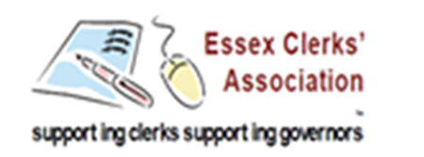

INFORMATION UPDATE
The following are links to information you might find useful for either yourself and/or your Governing Body / Board of Trustees
Careers guidance and access for education and training providers Statutory guidance for governing bodies, school leaders and school staff – January 2018
Changes to the teaching of Sex and Relationship Education and PSHE A call for evidence
GDPR Readiness Tracker
DfE Privacy Notices
Keeping Children Safe in Education 2017: Government Consultation
Keeping children safe in education Statutory guidance for schools and colleges: September 2018
NAHT Data and its use in schools
NGA School governance in 2017: An annual survey by NGA and TES
Ofsted Short inspections of good schools: A report on the responses to the consultation
Ofsted Annual Report of Her Majesty’s Chief Inspector of Education, Children’s Services and Skills 2016/17
Primary School Accountability: A Technical Guide
Primary progress measures How the primary progress measures are calculated
Primary school progress measure scores for key stage 2: school performance tables
Recruiting a headteacher: A guide to the recruitment and selection of headteachers and other leadership roles
Recruiting a headteacher toolkit
Sexual violence and sexual harassment between children in schools and colleges
Transforming Children and Young People’s Mental Health Provision: a Green Paper
Unlocking Talent, Fulfilling Potential: A plan for improving social mobility through education
UK Council for Child Internet Safety: Online safety in schools and colleges: Questions for the Governing Board

