CHILD PROTECTION POLICY FOR [INSERT NAME] SCHOOL

APPROVED BY GOVERNORS [INSERT DATE]

POLICY TO BE REVIEWED [INSERT DATE]

DESIGNATED SAFEGUARDING LEAD:

DEPUTY DESIGNATED SAFEGUARDING LEAD:

DESIGNATED SAFEGUARDING GOVERNOR:

INSERT SCHOOL LOGO AND / OR STATEMENT

Contents

1 | Introduction
2 | Statutory Framework
3 | Roles and responsibilities
4 | Types of abuse / specific safeguarding issues
5 | Procedures
6 | Training
7 | Professional confidentiality
8 | Records and information sharing
9 | Interagency working
10 | Allegations about members of the workforce
11 | Whistleblowing
Appendix A | Children and Families Hub Partner Access Map
Appendix B | PREVENT referral flow chart
Appendix C | Essex Windscreen of Need and levels of intervention

CHILD PROTECTION POLICY FOR [INSERTNAME] SCHOOL

- Introduction

Schools and their staff form part of the wider safeguarding system for children. Everyone who comes into contact with children and their families and carers has a role to play in safeguarding children. In order to fulfil this responsibility effectively, all professionals should make sure their approach is child-centred. This means that they should consider, at all times, what is in the best interests of the child.

(Keeping Children Safe in Education – DfE, 2016)

This Child Protection Policy is for all staff, parents, governors, volunteers and the wider school community. It forms part of the safeguarding arrangements for our school. It should be read in conjunction with the Safeguarding Policy, Safer Recruitment Policy, Staff Code of Conduct Policy, Physical Intervention Policy, Anti-Bullying Policy, Behaviour Policy, Health and Safety Policy, Educational Visit Policy, E-safety Policy, Social Media Policy and Photography Policy. (Add / delete policies as required) It should also be read in conjunction with Keeping Children Safe in Education (DfE, 2016).

Safeguarding and promoting the welfare of children is defined in Keeping Children Safe in Education as:

- Protecting children from maltreatment
- Preventing impairment of children’s health or development
- Ensuring that children grow up in circumstances consistent with the provision of safe and effective care
- Taking action to enable all children to have the best outcomes

2. Statutory framework

Section 175 of the Education Act 2002 (Section 157 for Independent schools) places a statutory responsibility on the governing body to have policies and procedures in place that safeguard and promote the welfare of children who are pupils of the school.

The development of appropriate procedures and the monitoring of good practice in Essex are the responsibilities of the Essex Safeguarding Children Board (ESCB). In Essex, all professionals must work in accordance with the SET Procedures (ESCB, 2017).

Our school works in accordance with the following legislation and guidance:

Keeping Children Safe in Education (DfE, 2016)
Working Together (HMG, 2015)
Education Act 2002
Effective Support for Children and Families in Essex (ESCB, 2017)
Counter-Terrorism and Security Act (HMG, 2015)
Serious Crime Act 2015 (Home Office, 2015)
Sexual Offences Act (2003)
Education (Pupil Registration) Regulations 2006
Information sharing advice for safeguarding practitioners (HMG, 2015)
Data Protection Act 1998
What to do if you're worried a child is being abused (HMG, 2015)
Searching, screening and confiscation (DfE, 2014)
Children Act 1989
Children Act 2004
Preventing and Tackling Bullying (DfE, 2017),
Female Genital Mutilation Act 2003 (S. 74 - Serious Crime Act 2015)

3. Roles and responsibilities

All adults working with or on behalf of children have a responsibility to protect them and to provide a safe environment in which they can learn and achieve their full potential. However, there are key people within schools and the Local Authority who have specific responsibilities under child protection procedures. The names of those in our school with these specific responsibilities (the designated safeguarding lead and deputy designated safeguarding lead) are shown on the cover sheet of this document.

The governing body

The governing body ensures that the policies, procedures and training in our school are effective and comply with the law at all times. It ensures that all required policies relating to safeguarding are in place and that the child protection policy reflects statutory and local guidance and is reviewed at least annually.

The governing body ensures there is a named designated safeguarding lead and deputy safeguarding lead in place.

The governing body ensures the school contributes to inter-agency working, in line with statutory and local guidance. It ensures that information is shared and stored appropriately and in accordance with statutory requirements.

The governing body ensures that all staff members undergo safeguarding and child protection training at induction and that it is then regularly updated. All staff members receive regular safeguarding and child protection updates, at least annually, to provide them with the relevant skills and knowledge to keep our children safe.

The governing body ensures that children are taught about safeguarding, including online, ensuring that that appropriate filters and monitoring systems for online usage are in place. Our children will be taught how to keep themselves safe through teaching and learning opportunities as part of a broad and balanced curriculum.

The governing body and school leadership team are responsible for ensuring the school follows recruitment procedures that help to deter, reject or identify people who might abuse children. It adheres to statutory responsibilities to check adults working with children and has recruitment and selection procedures in place (see the school’s ‘Safer Recruitment’ policy for further information). It ensures that volunteers are appropriately supervised in school.

The Designated Safeguarding Lead (and Deputy)

The designated safeguarding lead in school takes lead responsibility for managing child protection referrals, safeguarding training and raising awareness of all child protection policies and procedures. They ensure that everyone in school (including temporary staff, volunteers and contractors) is aware of these procedures and that they are followed at all times. They act as a source of advice and support for other staff (on child protection matters) and ensure that timely referrals to Essex Children’s Social Care (Family Operations Hub) are made in accordance with current SET procedures. They work with the local authority and other agencies as required.

If for any reason the designated safeguarding lead is unavailable, the deputy designated safeguarding lead will act in their absence.

The Headteacher

The Headteacher works in accordance with the requirements upon all school staff. In addition, (s)he ensures that all safeguarding policies and procedures adopted by the governing body are followed by all staff.

All school staff

Everyone is our school has a responsibility to provide a safe learning environment in which our children can learn. All staff members are prepared to identify children who may benefit from early

help and understand their role within this process. This includes identifying any emerging problems so appropriate support may be provided and liaising with the designated safeguarding lead to report any concerns. All staff members are aware of and follow school processes (as set

out in this policy) and are aware of how to make a referral to Social Care if there is a need to do so.

4. Types of abuse / specific safeguarding issues

Keeping Children Safe in Education (DfE, 2016) defines abuse as the maltreatment of a child.
“Somebody may abuse or neglect a child by inflicting harm or by failing to act to prevent harm. Children may be abused in a family or in an institutional or community setting by those known to them or, more rarely, by others (e.g. via the internet). They may be abused by an adult or adults or another child or children”

The four main types of abuse referred to in Keeping Children Safe in Education are:

- Physical
- Emotional
- Sexual
- Neglect

Our school is aware of the signs of abuse and neglect so we are able to identify children who may be in need of help or protection.

Peer on peer abuse

Our school may be the only stable, secure and safe element in the lives of children at risk of, or who have suffered harm. Nevertheless, whilst at school, their behaviour may be challenging and defiant, or they may instead be withdrawn, or display abusive behaviours towards other children. Our school recognises that some children may abuse their peers and any incidents of peer on peer abuse will be managed in the same way as any other child protection concern and will follow the same procedures.

Peer on peer abuse can manifest itself in many ways. This may include bullying (including cyber bullying), on-line abuse, gender-based abuse, ‘sexting’ or sexually harmful behaviour. We do not tolerate any harmful behaviour in school and will take swift action to intervene where this occurs. We use lessons and assemblies to help children understand, in an age-appropriate way, what abuse is and we encourage them to tell a trusted adult if someone is behaving in a way that makes them feel uncomfortable. Our school understands the different gender issues that can be prevalent when dealing with peer on peer abuse.

(Insert arrangements for prevention of and response to issues within your school – refer to any other relevant polices – eg. Anti-bullying policy)

Children with special educational needs and disabilities

Our school understands that children with special educational needs (SEN) and disabilities can face additional safeguarding challenges. Additional barriers can exist when recognising abuse and neglect in this group of children. This can include:

- Assumptions that indicators of possible abuse such as behaviour, mood and injury relate to the child’s disability, without further exploration
- Children with SEN and disabilities can be disproportionally impacted by things like bullying, without outwardly showing signs
- Communication barriers and difficulties in overcoming these barriers

Children missing from education

All children, regardless of their age, ability, aptitude and any special education needs they may have are entitled to a full-time education. Our school recognises that a child missing education is a potential indicator of abuse or neglect and will follow the school procedures for unauthorised absence and for children missing education. Parents should always inform us of the reason for any absence. Where contact is not made, a referral may be made to another appropriate agency (Missing Education and Child Employment Service, Social Care or Police).

Our school must inform the local authority of any pupil who fails to attend school regularly, or has been absent without school permission for a continuous period of 10 days or more.

Child Sexual Exploitation (CSE)
Child Sexual Exploitation (CSE) is a form of child abuse, which can happen to boys and girls from any background or community. In Essex, the definition of Child Sexual Exploitation (CSE) from the Department of Education (DfE, 2017) has been adopted:
"Child Sexual Exploitation is a form of child sexual abuse. It occurs when an individual or group takes advantage of an imbalance of power to coerce, manipulate or deceive a child or young person under the age of 18 into sexual activity (a) in exchange for something the victim needs or wants, and/or (b) for the financial advantage or increased status of the perpetrator or facilitator. The victim may have been sexually exploited even if the sexual activity appears consensual. Child

sexual exploitation does not always involve physical contact; it can also occur through the use of technology".
It is understood that a significant number of children who are victims of CSE go missing from home, care and education at some point. Our school is alert to the signs and indicators of a child becoming at risk of, or subject to, CSE and will take appropriate action to respond to any concerns. The designated safeguarding lead is the named CSE Lead in school on these issues and will work with other agencies as appropriate.
Female Genital Mutilation (FGM)
FGM comprises all procedures involving partial or total removal of the external female genitalia or other injury to female genital organs. It is illegal in the UK and a form of child abuse.

As of October 2015, the Serious Crime Act 2015 (Home Office, 2015) introduced a duty on teachers (and other professionals) to notify the police of known cases of female genital mutilation
where it appears to have been carried out on a girl under the age of 18. Our school will operate in accordance with the statutory requirements relating to this issue, and in line with existing local safeguarding procedures.

Forced marriage

A forced marriage is one entered into without the full consent of one or both parties. It is where violence, threats or other forms of coercion is used and is a crime. Our staff understand how to report concerns where this may be an issue.

Prevention of radicalisation

As of July 2015, the Counter-Terrorism and Security Act (HMG, 2015) placed a new duty on schools and other education providers. Under section 26 of the Act, schools are required, in the exercise of their functions, to have “due regard to the need to prevent people from being drawn into terrorism”. This duty is known as the Prevent duty.

It requires schools to:
- teach a broad and balanced curriculum which promotes spiritual, moral, cultural, mental and physical development of pupils and prepares them for the opportunities, responsibilities and experiences of life and must promote community cohesion
- be safe spaces in which children / young people can understand and discuss sensitive topics, including terrorism and the extremist ideas that are part of terrorist ideology, and learn how to challenge these ideas

- be mindful of their existing duties to forbid political indoctrination and secure a balanced presentation of political issues
CHANNEL is a national programme which focuses on providing support at an early stage to people identified as vulnerable to being drawn into terrorism. Our staff understand how to identify those who may benefit from this support and how to make a referral. (Appendix B)

5. Procedures

All action is taken in accordance with the following guidance;

- Essex Safeguarding Children Board guidelines - the SET (Southend, Essex and Thurrock) Child Protection Procedures (ESCB, 2017)
- Keeping Children Safe in Education (DfE, 2016)
- Working Together to Safeguard Children (DfE, 2015)
- ‘Effective Support for Children and Families in Essex’ (ESCB, 2017)
- PREVENT Duty - Counter-Terrorism and Security Act (HMG, 2015)
When new staff, volunteers or regular visitors join our school they are informed of the safeguarding arrangements in place, the name of the designated safeguarding lead (and deputy) and how to share concerns with them.

Any member of staff, volunteer or visitor to the school who receives a disclosure or allegation of abuse, or suspects that abuse may have occurred must report it immediately to the designated safeguarding lead (or, in their absence, the deputy designated safeguarding lead).

The designated safeguarding lead or the deputy will immediately refer cases of suspected abuse or allegations to the Children and Families Operations Hub by telephone (Appendix A) and in accordance with the procedures outlined in the SET procedures (ESCB, 2017) and in ‘Effective Support for Children and Families in Essex’ (ESCB, 2017).

The telephone referral to the Family Operations Hub will be confirmed in writing within 48 hours with the Children and Families Request for Support form. Essential information will include the pupil’s name, address, date of birth, family composition, the reason for the referral, whether the child’s parents are aware of the referral plus any other relevant information or advice given.

Wherever possible, the school will share any safeguarding concerns, or an intention to refer a child to Children’s Social Care, with parents or carers. However, we will not do so where it is felt

that to do so could place the child at greater risk of harm or impede a criminal investigation. On occasions, it may be necessary to seek advice from the Children and Families Hub and / or Essex Police in making decisions about when it is appropriate to share information with parents / carers.

If a member of staff continues to have concerns about a child and feels the situation is not being addressed or does not appear to be improving, the staff member concerned should press for re-consideration of the case with the designated safeguarding lead.

Safeguarding contact details are displayed in the school to ensure that all staff members have unfettered access to safeguarding support.

6. Training

The designated safeguarding lead (and deputy) undertake Level 3 child protection training at least every two years. The Headteacher, all staff members and governors receive appropriate child protection training which is regularly updated and in line with advice from the Essex Safeguarding
Children Board (ESCB). In addition, all staff members receive safeguarding and child protection updates as required, but at least annually, to provide them with relevant skills and knowledge to
safeguard children effectively. Records of any child protection training undertaken is kept for all staff and governors.

The school ensures that the designated safeguarding lead (and deputy) also undertakes training in inter-agency working and other matters as appropriate

7. Professional confidentiality

Confidentiality is an issue which needs to be discussed and fully understood by all those working with children, particularly in the context of child protection. A member of staff must never guarantee confidentiality to anyone about a safeguarding concern (including parents / carers or pupils), or promise to keep a secret. In accordance with statutory requirements, where there is a child protection concern, this must be reported to the designated safeguarding lead and may require further referral to and subsequent investigation by appropriate authorities.

Information on individual child protection cases may be shared by the designated lead (or deputy) with other relevant staff members. This will be on a ‘need to know’ basis only and where it is in the child’s best interests to do so.

8. Records and information sharing

Where there are concerns about the safety of a child, the sharing of information in a timely and effective manner between organisations can reduce the risk of harm. Whilst the Data Protection Act 1998 places duties on organisations and individuals to process personal information fairly and lawfully, it is not a barrier to sharing information where the failure to do so would result in a child or vulnerable adult being placed at risk of harm. Similarly, human rights concerns, such as respecting the right to a private and family life would not prevent sharing where there are real safeguarding concerns. Fears about sharing information cannot be allowed to stand in the way of the need to safeguard and promote the welfare of children at risk of abuse or neglect.

Well-kept records are essential to good child protection practice. Our school is clear about the need to record any concern held about a child or children within our school, the status of such records and when these records should be shared with other agencies.

Any member of staff receiving a disclosure of abuse or noticing signs or indicators of abuse, will record it as soon as possible, noting what was said or seen (if appropriate, using a body map to record), giving the date, time and location. All records will be dated and signed and will include the action taken. This is then presented to the designated safeguarding lead (or deputy), who will decide on appropriate action and record this accordingly.

Any records related to child protection are kept in an individual child protection file for that child (which is separate to the pupil file). All child protection records are stored securely and confidentially and will be retained for 25 years after the pupil’s date of birth, or until they transfer to another school / educational setting.

Where a pupil transfers from our school to another school / educational setting (including colleges), their child protection records will be forwarded to the new educational setting. These will be marked ‘Confidential’ and for the attention of the receiving school’s designated safeguarding lead, with a return address on the envelope so it can be returned to us if it goes astray. We will obtain evidence that the paperwork has been received by the new school and then destroy any copies held in our school.

Where a pupil joins our school, we will request child protection records from the previous educational establishment (if none are received).

9. Interagency working

It is the responsibility of the designated safeguarding lead to ensure that the school is represented at, and that a report is submitted to, any child protection conference called for children on the school roll or previously known to them. Where possible and appropriate, any report will be shared in advance with the parent(s) / carer(s). Whoever attends will be fully briefed on any issues or concerns the school has and be prepared to contribute to the discussions at the conference.

If a child is subject to a Child Protection or a Child in Need plan, the designated safeguarding lead will ensure the child is monitored regarding their school attendance, emotional well-being, academic progress, welfare and presentation. If the school is part of the core group, the designated safeguarding lead will ensure the school is represented, provides appropriate information and contributes to the plan at these meetings. Any concerns about the Child Protection plan and / or the child’s welfare will be discussed and recorded at the core group meeting, unless to do so would place the child at further risk of significant harm. In this case the designated safeguarding lead will inform the child’s key worker immediately and then record that they have done so and the actions agreed.

10.​ Allegations about members of the workforce

All staff members are made aware of the boundaries of appropriate behaviour and conduct. These matters form part of staff induction and are outlined in the Staff Handbook / Code of Conduct.
The school works in accordance with statutory guidance and the SET procedures (ESCB, 2017) in respect of allegations against an adult working with children (in a paid or voluntary capacity). Section 7 of the current SET procedures provides detailed information on this.

The school has processes in place for reporting any concerns about a member of staff (or any adult working with children). Any concerns about the conduct of a member of staff will be referred to the Headteacher (or the Deputy Headteacher in their absence). This role is distinct from the designated safeguarding lead as the named person should have sufficient status and authority in the school to manage employment procedures. Staffing matters are confidential and the school operates within statutory guidance around Data Protection.

Where the concern involves the headteacher, it should be reported direct to the Chair of Governors.
SET procedures (ESCB, 2017) require that, where an allegation against a member of staff is received, the Headteacher, senior named person or the Chair of Governors must inform the duty Local Authority Designated Officer (LADO) in the Children’s Workforce Allegations Management Team on 03330 139 797 within one working day. However, wherever possible, contact with the LADO will be made immediately as they will then advise on how to proceed and whether the matter requires Police involvement. This will include advice on speaking to pupils and parents and HR. The school does not carry out any investigation before speaking to the LADO.

11.​ Whistleblowing

Whistleblowing is ‘making a disclosure in the public interest’ and occurs when a worker (or member of the wider school community) raises a concern about danger or illegality that affects others, for example pupils in the school or members of the public.

All staff are made aware of the duty to raise concerns about the attitude or actions of staff in line with the school’s Code of Conduct / Whistleblowing policy.

We want everyone to feel able to report any child protection / safeguarding concerns. However, for members of staff who feel unable to raise these concerns internally, they can call the the NSPCC whistleblowing helpline on: 0800 028 0285 (line is available from 8:00 AM to 8:00 PM, Monday to Friday) or email: help@nspcc.org.uk.
Parents or others in the wider school community with concerns can contact the NSPCC general helpline on: 0808 800 5000 (24 hour helpline) or email: help@nspcc.org.uk.

Appendix A: Children and Families Hub flow chart

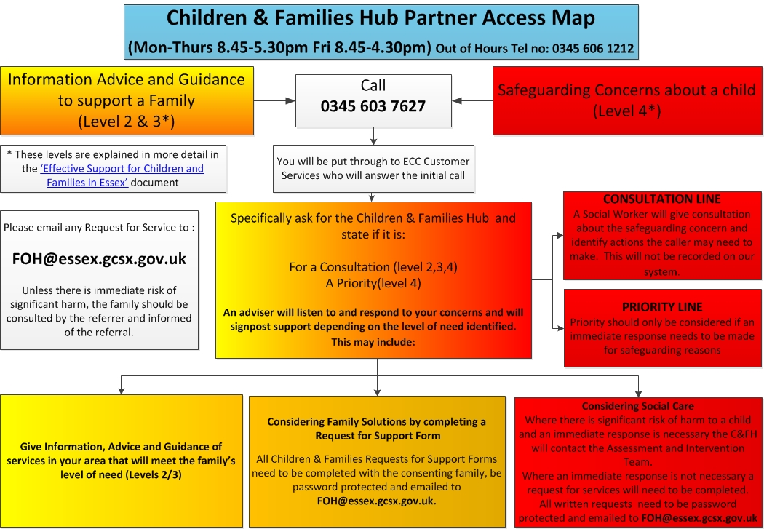

Appendix B: PREVENT Referral Flowchart

Appendix C: Essex Windscreen of Need and levels of intervention

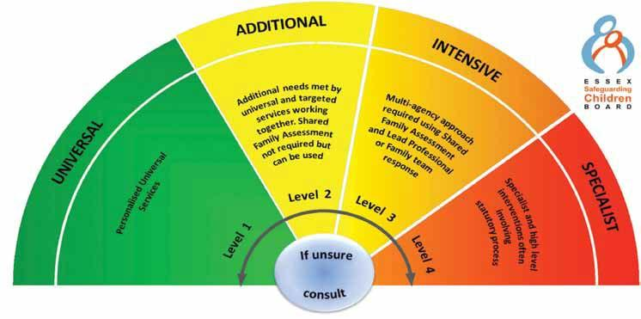

All partners working with children, young people and their families will offer support as soon as we are aware of any additional needs. We will always seek to work together to provide support to children, young people and their families at the lowest level possible in accordance with their needs

Children with Additional needs are best supported by those who already work with them, such as Family Hubs or schools, organising additional support with local partners as needed. When an agency is supporting these children, an Early Help Plan and a Lead Professional are helpful to share information and co-ordinate work alongside the child and family.

For children whose needs are Intensive, a coordinated multi-disciplinary approach is usually best, involving either an Early Help Plan or a Shared Family Assessment (SFA), with a Lead Professional to work closely with the child and family to ensure they receive all the support they require. Examples of intensive services are children’s mental health services and Family Solutions.

Specialist services are where the needs of the child are so great that statutory and/or specialist intervention is required to keep them safe or to ensure their continued development. Examples of specialist services are Children’s Social Care or Youth Offending Service. By working together effectively with children that have additional needs and by providing coordinated multi-disciplinary/agency support and services for those with intensive needs, we seek to prevent more children and young people requiring statutory interventions and reactive specialist services

