INFORMATION UPDATE
Summer Term 2018
The following are links to information you might find useful for either yourself and/or your Governing Body / Board of Trustees
2018 Benchmarking Report for Academies (Hacker Young)
Anti-Fraud Checklist for Academies (EFSA)
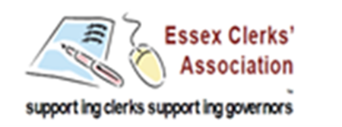
Being Strategic – A Guide for Governing Boards (NGA)
Careers Guidance: for FE & Six Form Colleges (DfE)
Cyber Crime & Cyber Security: a guide for academies (EFSA)
Data Protection: a toolkit for schools (DfE)
Designated Teacher for Looked After and Previously Looked After Children (DfE)
Eligibility for free school meals, the early years pupil premium and the free early education entitlement for two-year-olds under Universal Credit (DfE)
GCSE Information for Parents (DfE)
Managing Asbestos in Your School (EFSA)
Taking Headteacher Appraisal Seriously (NGA)
Ofsted:
- School Inspection Update v13
- What’s Changed in the Ofsted Handbook (in pack as well)
- Ofsted Inspection: A Guide for Parents
Schools Causing Concern (DfE)
The Right People Around The Table (NGA)

